

**Subject Teacher**

**Muhammad Owais Rehmani**

* + - **Name: Firza Ghori**
    - **Batch: 23**
    - **Roll No: 036**
    - **Subject: Programming Fundamental**
    - **Department: Artificial Intelligence**
    - **Assignment : nested loop**

**Submitted date: 2 - 12-2023**

**Exercise: 1**

**Half pyramid**

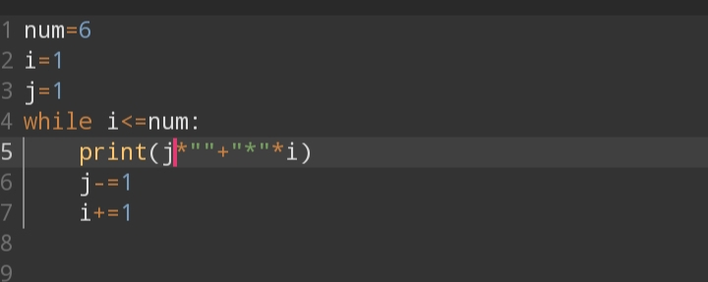

**Output:-**

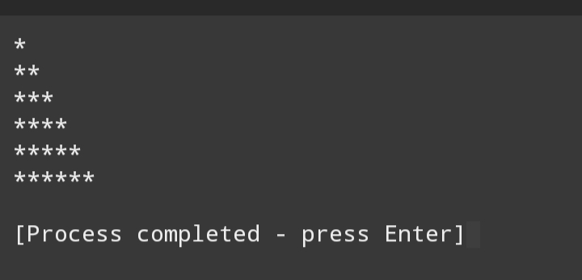

**Exercise: 2**

**Inverted half pyramid**

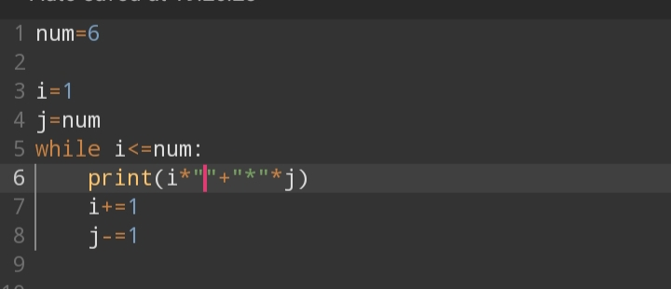

**Output;-**

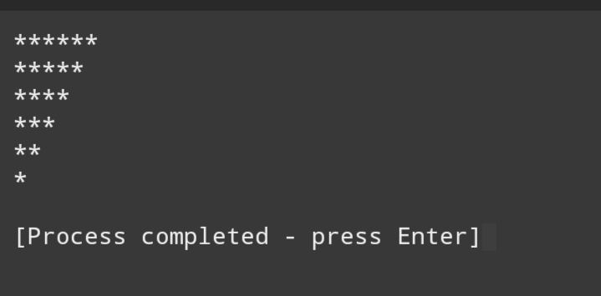

**Exercise: 3**

**Hollow inverted half pyramid**

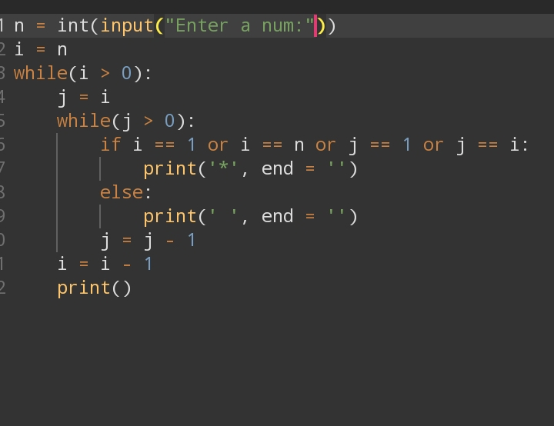

**Output:-**

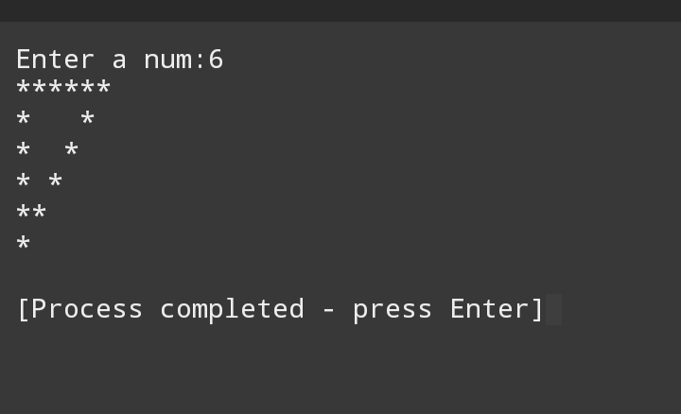

**Exercise: 4**

**Full pyramid**

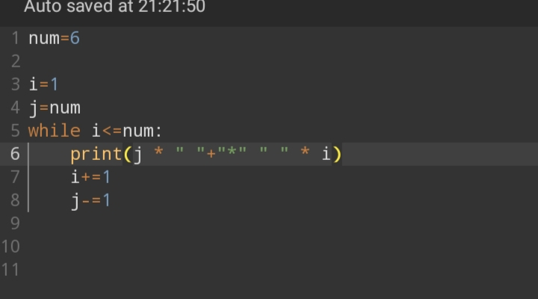

**Output:-**

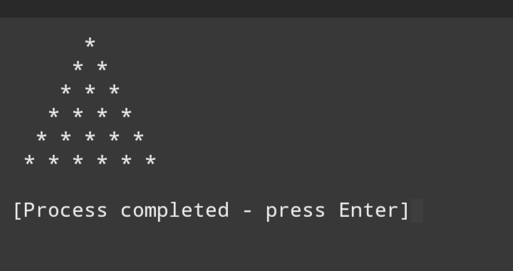

**Exercise: 5**

**Inverted full pyramid**

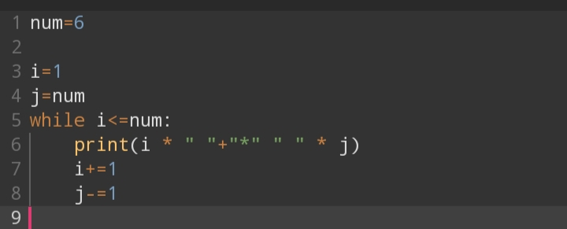

**Output:-**

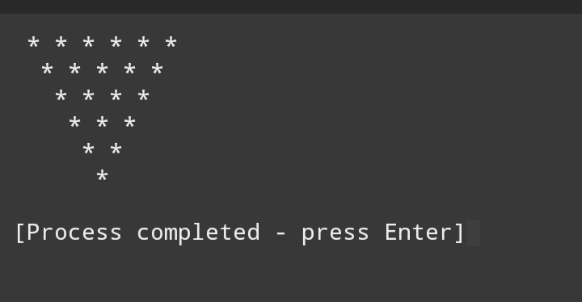

**Exercise: 7**

**Hollow full pyramid**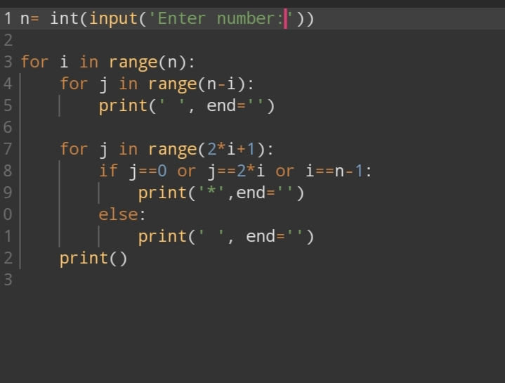

**Output:-**

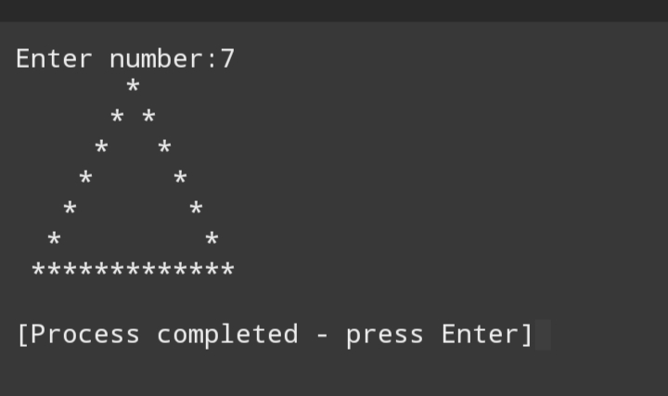

**Exercise: 8**

**Square fill pattern**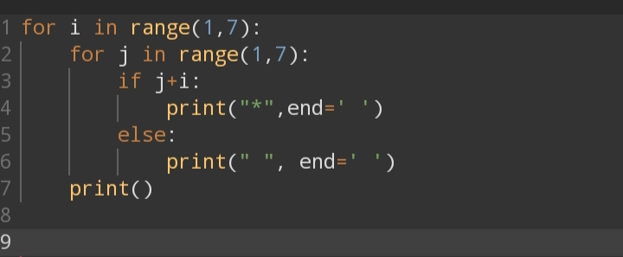

**Output:-**

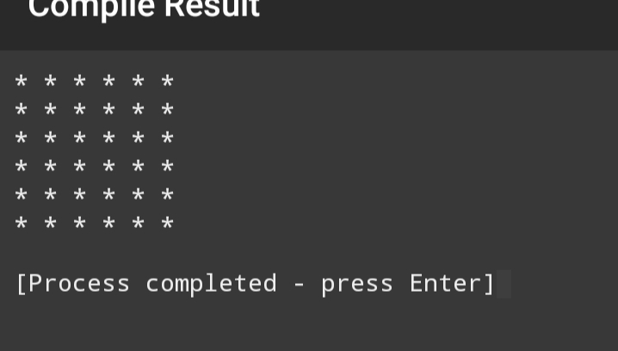

**Exercise: 9**

**Hourglass pattern**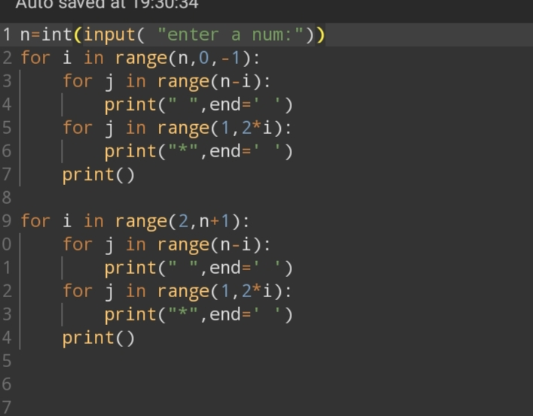

**Output:-**

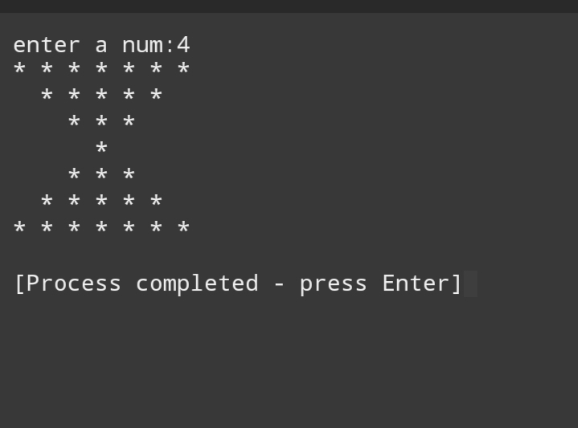

**Exercise: 10**

**Diamond pattern** 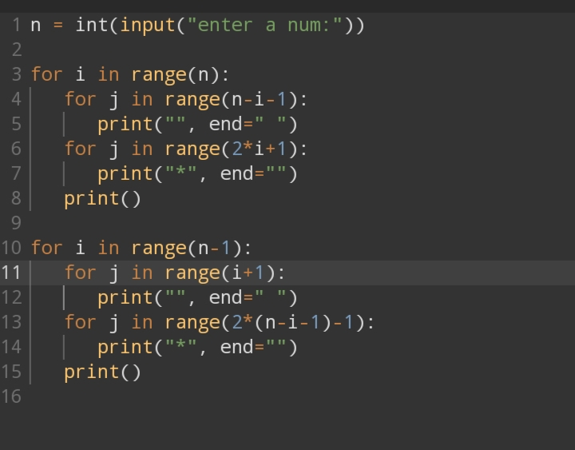

**Output:-**

